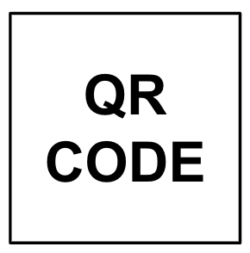
PREP  - Heaters on (Heat indicator lit!)  - 1X Inactivation Saline Soln ready  - Reaction mix strip8/plates ready  - Safety Procedures:  - lab coat  - gloves  - face mask  - face shield or goggles  - Alcohol wipe sample tubes |  | Log Link: SOP-103-B_1 {SITE}
 |  | Location:
 | Name:
Date:

Time:

INACTIVATION  - Add 1mL of 1X Inactiv Saline Soln to each sample tube  - Vortex 10sec (tubes) or 30sec (rack)  - Water Bath (set 99°C)  OR  - Heat 8 min then Cool 10 min  - Dry Heat Block (set 95°C)  - Heat 5 min then Cool 5 min | Sample Batch ID (from App):
 | Inactiv Heater:
 | 1X Inactiv Saline Soln ID:
 | Dispense: Pipette or Manual Disp or Electric Disp

AMPLIFICATION REACTION  - Thaw Reaction Mix (if frozen)  - Setup tips to align with reactions  - Add 2μL from each sample tube  (pipet up& down 5X, blowout in liquid, tip touch)  - Heat 65°C for 25 min, set timer  - Intake sample tubes in App  - Put sample tubes in fridge  - Remove Reactions and Let cool for 1 min before photo  - Take photo in lightbox  - Crop photo and apply vivid filter  - Update results in App  - Log Run with Form link | Amp Heater: |  | Strip8 Tubes or Plates
 | Reaction Mix: Frozen or Fresh
 | Reaction Mix ID:
 | Num Reactions (including controls):
 | Pos Ctrl ID:
 | Neg Ctrl ID (today's 1XISS):
 | Initial Inconclusives?:
 | Notes:

Lookup Map

 | 1 | 2 | 3 | 4 | 5 | 6
A 1
B 2
C 3
D 4
E 5
F 6
G 7
H 8

 | 7 | 8 | 9 | 10 | 11 | 12
A 1
B 2
C 3
D 4
E 5
F 6
G 7
H 8

